Faithonlyism
This is a made-up word that describes a made-up restriction placed on the Gospel message. The idea that a person needs only believe a series of facts (Jesus dies for my sins) is the typical message, which, as we’ve seen, is not the biblical message and is offensive. What if God only believed that Jesus’ sacrifice was all that was needed but did not send Him to die? Anyone who reads that question would think it ridiculous that God only had to believe for something to happen, yet that is what they say to the sinner. The problem is not their view of faith but the myths of faith and baptism they believe:
Myth #1: Faith only is biblical.
Truth: How dare anyone add even a single word to God’s written witness of His will and purpose in Christ Jesus (Compare Revelation 22:18. What is true of the Revelation of John is true of the whole Bible).
Myth #2: Baptism is a work that opposes faith. We know no one is saved by works (Ephesians 2:8-9).
Truth: Baptism is a time marker. Think of it like a birthday or anniversary. Does the day and hour give meaning to the event? Of course not. But, would there be an event with meaning without the day and time?
Myth #3: Ephesians 2:8-9 is proof for faith only.
Truth: Faith is used with a form of save only three times in the New Testament from Acts through Revelation. This is in Ephesians and James. James is the only time faith only appears and he says that faith alone cannot justify. Plus, one passage does not override all others. They are all true and equal.
Conclusion: Where the Bible Speaks …
Do It without question or creed!
All Authority has been given …
Three Commands:
- Make Disciples
- Baptize
- Teach
Jesus said it
We Believe it
That settles it!
Why did Jesus command us to baptize the Disciple in the Great Commission?

The Baptism Debate
All Christian faith traditions agree regarding the place of baptism as a sacrament in the church. However, not all agree on the purpose, age, or condition of the person being baptized. If the purpose can be determined, the rest will fall into place. Let’s start with some background.
History
Until the Reformation, there was not dispute or debate about the purpose of baptism. While it took only a century for infant baptism to become the common practice, the purpose was never questioned. It was for the forgiveness of sins. While the earlier Apostolic Creed did not include baptism, it did include forgiveness. It was in the Nicene Creed that the church imbedded baptism for the remission of sins into their creedal theology.
In fact, Luther still practiced baptism the way he always had. It was his disciples and other Reformers who changed the teaching, assuming Luther’s faith only could not possibly include baptism.
In 1562, the Second Helvetic Confession changed the verbiage regarding baptism from actual to symbolic, drawing a distinction between physical and spiritual, based on Greek philosophy. shift changed to signs and symbols so that physical water could deliver no spiritual benefit nor be connected to those benefits.
Jumping ahead, the contemporary evangelical uses a simple prayer that is designed to invite Jesus into the sinner’s heart. This is based on the faithonlyism of the Reformation.
Let’s Dig Deeper
If a person removes the filter of their denomination and creeds, they will find a very clear picture of the apostolic ideal for baptism. Now, having seen the biblical evidence, let’s drill down.
Essential Nature of Baptism
Baptism has at least Four Essential Qualities:
- It is time and place the blood of Jesus removes our sins (Acts 2:38; 1 Peter 3:21). The water is the time and place, not the means (compare Romans 6).
  - Hebrews 9:14: The blood cleanses the conscience from dead works to serve
  - 1 Peter 3:21: Baptism saves being an appeal to God for a good conscience
- As forgiven people, the Holy Spirit can now reside in us (Acts 2:38). Now, we are clean enough to serve (Titus 2:14; Hebrews 9:14).
- It is how a believer obeys the form of the Gospel (Jesus’ Death and Resurrection; Romans 6:17). Baptism is the believer’s burial providing the time and place to meet Jesus at His death and resurrection.
- It is the time and place that the believer is clothed with Christ! It doesn’t get any more personal than this.
Question: Can anyone be saved and not …
- have their sins forgiven?
- receive the Spirit?
- contact the Gospel?
- clothe themselves with Christ?
ABSOLUTELY NOT! Baptism is a gift of God’s saving grace (1 Peter 3:21; Mark 16:16).
Acts – The Book of Evangelism
The book of Acts is the only book in the New Testament that gives us the message that Christians gave to non-Christians. We’ve seen in Peter’s message that faith, repentance, and baptism were required. Let’s examine the other accounts of the presentation of the Gospel.
Text | Actions
Pentecost  Acts 2:14-21, 38, 47 | Repentance  Baptism
Samaria  Acts 8:5-12 | Belief  Baptism
Simon | Belief  Baptism
Eunuch  Acts 8:35-39 | Confession  Baptism
Saul-Paul  Acts 1-18 | Baptism
Cornelius  Acts 10:34-48 | Belief  Repentance  Baptism
Lydia  Acts 16:25-34 | Baptism
Corinthians  Acts 18:8 | Belief  Baptism
Disciples  Acts 19:1-7 | Baptism
In every instant, without exception, baptism is commanded or performed even though faith and repentance were mentioned or implied in the Gospel message.
Study to Show Yourself Approved
Don’t just trust me. Go and study these passages. By the way, leave your creeds at home when you do. The Bible is the only authority!

The Sinner’s Prayer
The sinner’s prayer is a very contemporary method used to publicly identify a faith only conversion. This may be helpful.
A Little History
Many evangelical pastors have concluded a sermon by asking non-Christians to “ask [receive, or invite] Jesus into their heart,” or to pray some version of the “sinner’s prayer.” The phrase to “ask Jesus into your heart” for conversion is not biblical. So where did this prayer originate? This idea of “receiving Christ into your heart” became more formalized as a non-Christian’s prayer of conversion during the great missionary movement of the 19th century. This became a useful way to explain the need to make a personal decision to follow Christ This is confirmed by Paul Chitwood in his PhD thesis on the “Sinner’s Prayer: An Historical and Theological Analysis.” He states, “The Sinner's Prayer originated in the early twentieth century as a result of efforts to simplify and reproduce methods in evangelism. Billy Graham is given primary credit for popularizing the prayer.”² Scot McKnight sees the influence of Graham but stops the buck with Bill Bright and the Campus Crusade movement. See his overview of the history of the simplified gospel in chapter 6, “The Gospel of Revivalism” in The King Jesus Gospel (Zondervan, 2011).
“Vague decisionism,” as Thomas Lewellen calls the sinner’s prayer doesn’t work for the Bible believing and practicing servant of Christ. Rather, since the Bible is the authority, wouldn’t it be best to see what it says about salvation and the place baptism has in God’s plan?
Question: How can the Reformed based teaching be correct when introduced over 1500 years after the New Testament and never practiced? This latter-day revelation opposes biblical teaching. The real question is where do we begin in a biblical study to find the purpose of baptism.
Start with Jesus
Hebrews 12:2 tells us that Jesus is the author and perfecter of our faith because “who for the joy set before Him, endured the cross, despising the shame, and has sat down at the right hand of the throne of God.” This is the position of authority that gave Him the right to command baptism.
First, Jesus’ His baptism (“in this way”) was essential to “fulfil all righteousness” (Matthew 3:15). While His baptism was not for forgiveness, it did “all righteousness.” His validation of baptism set the stage for the purpose taught by the early church. What was that purpose?
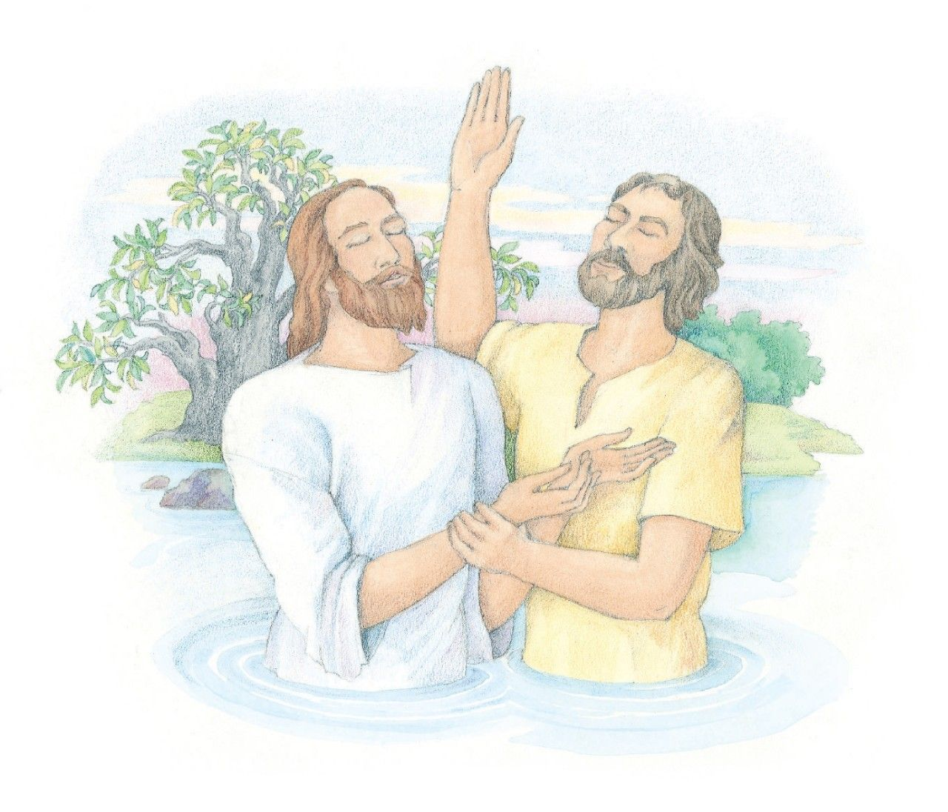
By the way, Mark and Luke also record Jesus’ final commission:
- Faith and Baptism are guarantees of future salvation (Mark 16:16)
- Repentance for forgiveness is the heart of the message (Luke 24:47)
Let’s compare Jesus’ last words to the first message preached by Peter on the Day of Pentecost. This will validate how the early church understood Jesus.
The Faith Once Delivered (Jude 3)
Jesus’ commission involved faith, repentance, and baptism. Are these elements part of Peter’s presentation? Let’s break down the sermon (Acts 2):
Faith
Faith must have an object. This is where Peter begins:
- Knew He fulfilled what was predicted by the prophets of Israel (Acts 2:16-21)
- Was recognized by the people as the son of Israel’s King, David (Acts 2:25, 30)
- Attested by God (Acts 2:22)
- Died on a cross, which is an unquestioned, historical fact (Acts 2:23)
- Was buried (implied; Acts 2:24)
- Was declared the Son of God with power by the resurrection from the dead (Acts 2:36)
- Was crowned King of God’s kingdom in this world (Acts 2:36)
- Has the right to judge (Acts 2:34)
Repentance
Repentance means to change your mind. Today, when the Gospel is preached, people are asked to repent of their sins. The only sin Peter mentioned is that they killed Jesus, not accepting Him as their Messiah. Peter asked them to change their mind about Jesus. He is asking them to believe Jesus is their Messiah. (By the way, shouldn’t that be our focus?) (38).
Baptism
In response to being convicted (37), Peter connects repentance and baptism to the remission of their sins (rejecting Jesus and related sins). This is required before the gift of the Spirit can be given (implied in the text -- will receive) (38).

