Your Church
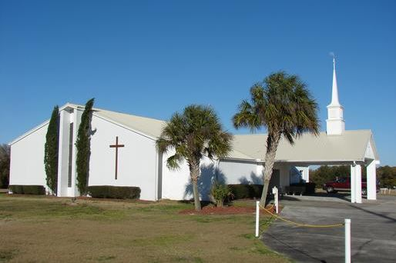

Adult & Children Sunday School 9:00 am
Sunday Worship 10:00 am
Wednesday Bible Study 6:00 pm
You honored us by your presence
This is a sample title and message that the minister would write. No more than 90 words. We consider it an honor that you chose to be with us in our celebration of King Jesus. Our prayer is that you saw our vision to be a loving, caring church put into action. We are committed to this as demonstrated by our mission to present Christ Jesus as Lord and Savior at every opportunity. This is achieved by holding God’s word as the standard for our faith and God’s love as demonstrated in Jesus as our motivation.
Life’s Ultimate Questions
Street Address Minister/Pastor
City, St Zip
(xxx) xxx-xxxx www.yourwebsite.com
Vision:
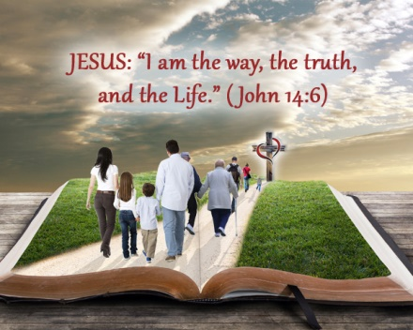
Journey with us to find the answer to questions about God, Jesus, and the Christian experience!
God has promised to give us Good News regarding Jesus who was declared to be the Son of God with power by the resurrection of the dead (Romans 1:16-17).

What’s the Question?
What are Life’s Ultimate Questions? While there are many important issues that raise questions in our lives, most will admit that there are few as important as how we are to live this life and where we will spend eternity.
Many religious traditions provide multiple answers to these questions. At Your Church, we believe that the bible is the only reliable source to answer them. Why? Look at what the bible states:
“God promised Good News long ago through his prophets in the Holy Scriptures. The Good News is about His Son” (New Living Translation, 1:2-3).
Your Church is here to help you find the answers to these important questions about how to live this life and how to assure our eternal destiny. To do this, please take a journey with us down the Romans’ Road. Romans is one of the books of the Christian Bible that gives the clearest answers to these questions. This journey walks you through the book of Romans to see what God has told us about our current relationship with him and how that could affect where we will spend eternity. As you take this journey, you will see numbers in parenthesis. These are the chapters and verses in Romans where these important truths are found

Finding the answers along the Romans’ Road.
Here is our first stop:
“The wrath of God is revealed from heaven against all ungodliness and unrighteousness of men who suppress the truth” (1:18-19).
The reason God is angry is because all of us fall short of His expectations (3:23).
Wait! Don’t be discouraged. There is hope. There is another way for us to go on the road of life. While God has revealed his wrath, He has also revealed his righteousness. He did this through the faithfulness of Jesus, his Son (3:21-25).
You see, a long time ago, God made a promise to a man named Abraham that would offer humanity the solution to this problem. Based on this promise, “Abraham believed God, and it was credited to him as righteousness” (4:3). Abraham did not waiver, but grew strong in his faith, “being fully assured that what God had promised, He was able also to perform” (4:20).
God credited him as righteous because of his faith. However, it was not just for Abraham. It was for our sake that He “raised Jesus our Lord from the dead, He who was delivered over because of our transgressions (another word for sins), and was raised because of our justification” (4:24-25). Justification means that God will not condemn us. Rather, he rescues us by paying a ransom to free us from the power of sin.
Peace with God
“Therefore, having been justified by faith, we have peace with God through our Lord Jesus Christ, through whom also we have obtained our introduction by faith into this grace” (5:1-2).
The point of faith is that Jesus is God’s Son and that he was the demonstration of God’s love. We believe that his death was for our benefit, freeing us from the penalty of sin (5:8).
Like Abraham, when God tells us what he will do for us because of what Jesus did on the cross, we change our minds about who should be in control of our lives. We come to the conclusion that Jesus is Lord because he not only died for us, but also defeated our worst enemy, death! Now, we need to unite with Him.
United with Christ Jesus
“Thanks be to God that though you were slaves of sin, you became obedient from the heart to that form of teaching” (6:17)
How do you OBEY the form of the Gospel?
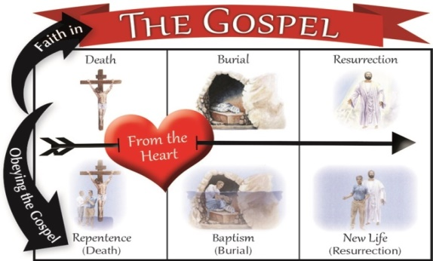
(6:1-4)
The Straight and Narrow!
The Christian life is a straight walk on a winding road! We will often struggle. There are hills and valleys, curves and slick roads ahead for the Christian. However, there is also a great promise we find on the Romans’ Road.
“Wretched man that I am! Who will set me free from the body of this death? Thanks be to God through Jesus Christ our Lord! Therefore there is now no condemnation for those who are in Christ Jesus. For the law of the Spirit of life in Christ Jesus has set you free from the law of sin and of death” (7:24-8:2).
Remember the wrath of God at the start of the journey? That was a judgment God brought against humanity because of our ungodly and unrighteous ways. The charge of guilty has been removed and now you are no longer condemned. Why? Because you …
- Believe Jesus is God’s Son
- Believe he died and was raised again
- You have united with him in baptism, and
- You now live by the Spirit of Life, God’s Spirit living in you.
Therefore there is now no condemnation for those who are in Christ Jesus.
“Conformed to the image of Jesus, we ask, “Who will bring a charge against God’s elect? Christ Jesus is He who died, yes, rather who was raised, who is at the right hand of God, who also intercedes for us. Who will separate us from the love of Christ?” (8:33-35)

