What Did He Communicate?
If the universe is the source of life, we are the product of our DNA. However, if created by the God we have described, then we are also of that same nature. It looks like this:
- If A creates B and
- If A has the quality of Q, then
- B has the quality of Q
Things Changed
The Big Bang and Evolution theories contend that changes were forced on the world and living organisms. God’s creation experienced a change by choice. God made a perfect world for them with a perfect plan to live together with them in perfect harmony. When the first humans decided to oppose the plan, it introduced death into the world. Like above, this makes us want to live for the moment and by our own rules.
However, God still loves His creation, so He had developed a plan in case humans made the wrong choice. This would be His greatest and most compassionate interaction because He would make this statement through His Son, Jesus.
God had predicted that His Son would come to earth one day. His arrival would be unique. His mother would be through the royal line of King David while His Father would be God Himself. God would come to Mary (Jesus’ mother) and impregnate her by His Spirit, without sexual intercourse.
The Jewish and Roman world Jesus grew up in hated Him because He said He came to set up God’s Kingdom on earth. They killed Him. This is a historical fact. Thanks be to God, Jesus defeated the power of death by resurrecting from the dead, also a historical fact. His defeat of death raised Jesus to the place of being God’s King in His kingdom on earth. Now, Jesus is looking for disciples who will join with Him to help more know about God’s love. Sure there are rules, but they protect us and honor God.
Would you like to know more about Jesus and how to be His disciple? Just ask me.
Only Two Options
Which is the Most Logical?
Non-Logical, Non-Thinking, Impersonal Entity
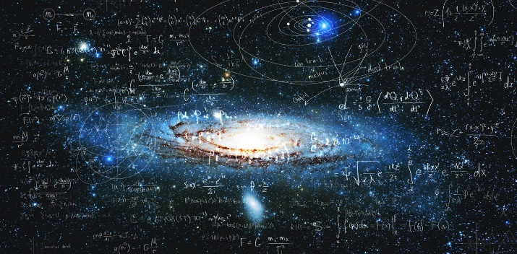
OR
Eternal, Logical, Thinking, Creative Entity
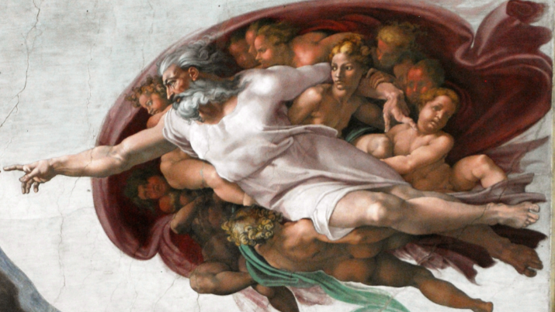

It will take you about 5 minutes to read this booklet. It may be the most important 5 minutes of your life! It’s time to consider the evidence.
The Options
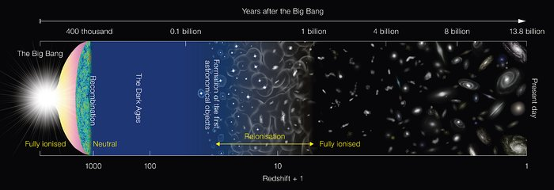
Non-logical, non-thinking, impersonal entity that is eternal and possess no inherent capability to create that developed or naturally had a primordial soup and enough energy to produce and sustain movement that ultimately leads to a collision, generating a primitive and simple life form that evolves due to environmental influences that do not last as long as the time needed to make even an initial change.
OR
An eternal, logical, thinking, creative entity that generates a complex, organized, and systematic world that can replicate itself through natural means.
The only logical option is #2! Anyone who looks at this wonderful, complex world would know that it must be the natural outcome of a complex entity. Science cannot explain
Ready to weigh some evidence?
by mathematical odds, will they communicate with their creation? If they will, how will they communicate?
Methods of Communication
Nature
We’ve already pointed out that the complexity and structure of the world demands a creator. Allow me to contrast this to evolution. Evolution is based on the theory that life changed primarily due to environmental changes that threatened the living organism. However, according to scientists, the threatening issue did not last as long as was needed to develop even the first enzyme. This raises the question of why the change continued when the threat was gone! A fully developed creation with the ability to adapt will survive naturally until the natural corruption set in. Thus, nature from this perspective “declares the handiwork of God.”
History
All faith traditions have numerous stories of how their history was affected by their deity. However, only Christianity has a long history with a written record of their God’s interaction with them. This history is confirmed by archaeology and held faithfully by the Jewish nation as it was their history.
Written Record
With all traditions there is a question regarding the reliability of their written record. Mohammed, Confucius, Joseph Smith, and so on wrote or produced much of the original material for their sacred writings. Here is the issue: these were mere men who gave no evidence nor had witness to any divine or miraculous claims to validate their writings. The Christian writings have been historically validated and come from a common textual base that was the same across the three major areas of concentration of early Christianity. This means that a single text came from three different cultures and locations. This single text was substantially the same with minor differences in spelling and grammar.
The Conclusion: The eternal, logical, thinking, creative, and personal deity communicated with the complex, organized, and systematic world it created. This makes it personal!
Sports
- You are under team and association rules
- You are penalized for stepping outside of the rules
- Individual sports (golf, track & field, etc.) also have association rules as well as rules for the sport’s society
- There are expected levels of behavior that given
We can continue to breakdown other life experiences like dating and marriage, social norms, laws, etc. No one is an island; we all realize we are part of a greater whole. So, where does individual choice come into play? It is when we feel that someone or something is limiting us from having the fun we desire or achieve the results for which we work or play.
Paradigm Shift
God is NOT a cosmic killjoy! That’s right, it is not His job to take away all your fun. Rather, He wants to show you how you can get the most out of this life AND not fear death.
Fear of Death
Do you realize how driven we are by the fear of death? We set goals, make bucket lists, and try our best to get the most out of this life before we die. There is an old, appropriate saying for this:
Eat, drink, and be merry for tomorrow we die!
Like the beginning of time, we know little about life after we die. Despite what Christianity and other religious traditions tell us, it is still an uncertainty for most. No matter how many books about seeing the light, out of body experiences, and so on, there are still doubts and fears.
Inaccurate Pictures
Unfortunately, many faith traditions have given a poor image of the expectations of their God. They make up rules and regulations based on the personal beliefs rather than the revealed thoughts of God. To do this, there is an important question we must consider. If there is an organized, structured world from a source that was structured and organized or an organized, structure universe that makes life only
Fact
There is NO evidence for any position on the origins of either the universe or a personal entity that creates. There are theories and arguments. Thus, the only way to determine this is by logic.
The Universe
The Universe and the Big Bang (Most accepted view)
PRO | CON
Expanding Universe | Only a theory  Do Direct Evidence
https://usm.maine.edu/planet/how-do-you-know-big-bang-occurred
Cosmic Background Radiation  Elemental Composition of the Universe | No Direct Evidence  “Evidence is apparent …is thought to be  “Correlations between these observations and the predictions”
https://louisville.edu/planetarium/research/implementation/visualization-scripts/high-school/hs-module-1
This is just two resources, and you will find more with the same language. Theories are designed to offer “possible” answers but notice the language of science:
- Apparent
- Thought to be
- Observations and the predictions
This is NOT scientific evidence. These are theories based on observations from the current status of the universe that are then made into explanations of a changing universe and its origins. This is not logic; this is guesswork and supposition. Thus, it takes a lot of faith to put your trust into “apparent,” “thought to be” and “predictions.” If you believe you have an eternal soul and there is the possibility of something after death, are you willing to risk that based on this type of logic?
The Divine
Since there is no evidence, how do we present an eternal, logical, thinking, creative entity that generates a complex, organized, and systematic world that can replicate itself through natural means. We do this with logical assumptions from scientific evidence.
Scientific Evidence
With a single voice, the scientific community declares that our current world is logical (natural law?) and organized. Isn’t it more logical to think that this was the product of a complex entity who was able to duplicate their nature?
PRO | CON
“Natural Law” has to have a “Law maker” | Laws of the universe were self-created
Energy cannot be created so the energy to make life must have been in existence within an entity who could use it to create | Uncontrolled energy was present that would inevitably cause a collision of particles that would produce life (energy?)
Humanity naturally wants to create, which is an indication of coming from a creative source | Creating is the outgrowth of the survival instinct
Human desire for a moral standard cannot come from DNA or an inanimate source | Society produces moral norms
As you can see, the arguments are balanced, but which makes the most sense. An organized, structured world from a source that was structured and organized or an organized, structure universe that makes life only by mathematical odds?
Maybe this bumper sticker has the right message:
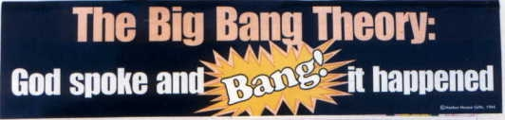
Making a Conscience Decision
So, be perfectly honest, both positions are a matter of faith! Do you trust science, which, by the way, is only of later development and comes from the religious thought that science is possible only because of an organized, systematic, creative being? Or do you trust the thousands of years of cultural and phenomenal evidence that gives credence to a superior entity interacting with the created world?
Before you conclude, consider this:
Truth Be Known!
Is it possible that there is a hidden, inner motivation to choose the scientific route over the Christian perspective? Truth be known, there is. This is a driving force that is inherent in most people. What is it?
It is the passion to be in control of one’s own life!
You see, at the very moment you admit that there is a powerful, creative entity, you must also admit that they have the right to tell you how to live. After all, if they make you, shouldn’t they have the right to some type of oversight? One possible way to approach this is to see if we really are in control of our own life.
Life Scenarios
Employment: Work for someone
- If you work for someone else, you are under their control for the expected time to produce the expected results
- They set expectations for your (quotas, productivity levels, etc.)
- They typically have expectations of certain kinds or levels of behavior
- Some will even tell you how to dress
Employment: You are the boss
- The bottom line controls you
- The bottom line tells you if you are working enough
- Your name on the business sets the behavioral expectations
- In many respects, the customer is your boss

