Now…What About Church?
It is obvious that God has limited His control because the world is still a mess. So, where is God in control? He is controlling the church under the Lordship of King Jesus. The church is designed to be an outpost for the heavenly kingdom under the control of Jesus, advancing God’s plan in our world.
The Kingdom of the Beloved Son
You may hear or say this, “I do not like organized Christianity.” What is meant is they don’t like the churches they see today. However, when you know what church really should mean, it makes more sense.
The Real Church
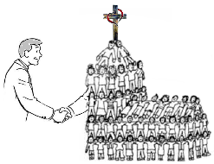
Church means that you are now in a proper, friendly relationship with God in King Jesus. It is a place to be with other believers who, like you, want to learn more about what King Jesus taught us. Thus, the local church is the physical body of disciples for that location, doing the ministry of making new friends of God through the gospel of King Jesus.
Learn more about Jesus and His church at …

Dr. Paul R. McCuistion
Teaching4Jesus Ministries
(813) 310-1110
www.Teaching4Jesus.org/
A Tale of Two Kingdoms
It was the best of times,
it became the worst of times,
It was the age of wisdom,
now, it is the age of foolishness.
Where is the hope for this
Dark Kingdom?
The Good News is inside!
A Dark Kingdom
Before recorded time, God spoke a perfect world into existence, and it was good. No danger, sickness, or problems. Sounds perfect, right? Well, most know what happened. If you don’t know the story, you know the outcome.
Here’s what happened. The first people became self-centered and stepped out line (the Bible calls this transgression). They paid more attention to what they wanted that satisfied their bodies than what the Creator planned for them. They thought things would be better. They weren’t. Things didn’t work out like they thought it would.
The Result: It became a very dark world that holds power over all of us. How does it do this? DEATH! That’s right, death. You see, God told the first people that the choice they made introduced death into that perfect world. You see, it is through fear of death we are made slaves to our bodies, living more for the moment than for eternity. Because of this, we make choices with eternal consequences, and with all our knowledge, can’t avoid the fact that one day we will stand before an eternal God who will ask us to give an account of our lives.
Conclusion: While there is some good in this world, on the whole, it is a dark kingdom whose authority over us drives us to live for ourselves.
Now for the good news.
A New Life!
If you have obeyed from the heart the form of the teaching, you belong to King Jesus. “You are not your own? For you have been bought with a price. Therefore, glorify God in your body.”
Transferred
Once you are transferred into the kingdom of the Beloved Son, your citizenship changes. You …
- … learn to live under kingdom rules
  - One purpose of the church is to teach you the rules
- … share the Good News with others of who Jesus is and what He has done so they can benefit from citizenship in the beloved kingdom
- … help increase God’s influence in the world
Now, Serve Like Jesus
“For even the Son of Man did not come to be served, but to serve, and to give His life a ransom for many.”
Having Jesus’ Spiritual DNA, we will serve. How?
- By finding a local body of believers and learning what Jesus has taught us
- By serving Lord Jesus in a local body of believers, using your natural abilities and the gifts the Spirit will give you
- Living as a new creation, promoting Him through His body on earth – the church
- Proudly serve as His Ambassador, spreading the Good News about Jesus
Here’s How This Works
The form of the Gospel is Jesus’ death, burial, and resurrection, which were historical realities. To obey the form, the Bible tells us that we must be baptized, which is our moment in history when we are bought with the precious blood of Jesus and transferred into His kingdom. Picture it this way:
Here are the benefits of obedience:
  - His death – forgiveness of past, present, and future sins and their consequences
  - Burial – die to our sins so we can be raised in His likeness to live under His kingdom rule
  - Resurrection – made to be like Him by His Spirit that raised Jesus
    - Jesus gives us the gift of His Spirit to live in us and keep the picture of Jesus fresh in our hearts and mind
    - The Spirit does this by sharing Jesus’ nature with us, helping us value Jesus more
The Beloved Kingdom
God has taken charge in an unexpected way in and through Jesus. What does this mean? Let’s take a look at God’s unique plan to regain control. It is a simple, perfect plan. Here it is in a nutshell:
The Gospel (Good News) about Jesus
Jesus appears in human history many years ago, yet He existed before His entrance into our world. His birth had been predicted, anticipated, and realized after years of preparation. God in and as Jesus came here to restore His rightful place as ruler over this world. To accomplish this, Jesus had to die, but thanks be to God, He conquered death, giving humans hope by taking away the fear that death uses to control us. By His resurrection, God has made Jesus Lord (King) over those who believe in Him and are willing to let King Jesus rule over their lives as citizens in His kingdom.
Where Do We Start?
The foundation of the Christian faith is what you think of Jesus, which means you must believe:
- God is real and creator of all we see and know
- Jesus was a real person God had predicted would come and set things in order
- Jesus came to do God’s will
- Jesus is God in bodily form, and this was proven by the miracles He did and His resurrection
- God raised Him to a place of absolute authority over the world
- Jesus will come back to earth to judge the world
More about Jesus
- He is the way, the truth, and the life. No one comes to the Father but through Jesus
- God highly exalted Him, and gave Him the name which is above every name
Also, Jesus …
- … knew He fulfilled what was predicted by the prophets of Israel
- … was recognized by the people as the son of Israel’s King, David
- … spoke with authority, telling people what God wanted them to know
- … died on a cross, which is an unquestioned, historical fact
- … was buried as proof of His death
- … was declared the Son of God with power by the resurrection from the dead
- … was crowned King of God’s kingdom in this world
- … has the right to judge our lives!
Conclusion:
Why is this Good News?
Jesus is Lord over God’s kingdom!
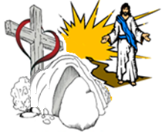
You can become a citizen in God’s kingdom Here’s how this works:
- Become Jesus’ Disciple. This means that you believe God has given Jesus the authority to rule over your life and you will follow His teachings.
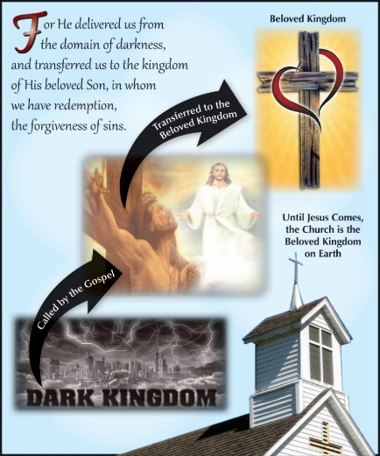
- Become Qualified. This is through the forgiveness of past, present, and future sins through the death and resurrection of King Jesus.
- Be Rescued. Under the Lordship of King Jesus who ransoms you from the control of lord of this dark world by His resurrection.
- Freed from the fear of death, God Transferers Us “into the kingdom of His beloved Son” under the Lordship of King Jesus
Why Did God Do This for Us?
Although we rebelled by the way we acted, God demonstrates His own love toward us, in that while we were yet sinners, He redeemed us through the blood of Jesus, separating us for service to King Jesus.
OK, I’m in! Now What?
To become a citizen under Jesus’ rule, you must:
- Be transferred into Him by obeying the Gospel
- “Thanks be to God that though you were slaves of sin, you became obedient from the heart to that form of the teaching.”

